**mystical forest in Mawphlang**

Located about 26 kms from Meghalaya's state capital Shillong, Mawphlang Sacred Forest is also known as Lawkyntang. According to information available on Trawell.in Mawphlang Sacred Forest is the most well-known amongst all the sacred forests in Meghalaya.

According to the locals, the sacred forest is protected by the Lyngdoh clan, who believe that the deity Labasa resided here. The villagers believe that the deity protects their village during crisis. The forest also serves as an important ritual site for the people of Hima Mawphlang who perform various thanks­giving and blessing ceremonies in the area. Members of the Khasi tribe also burn the bones of their dead inside the forest.

1st image:

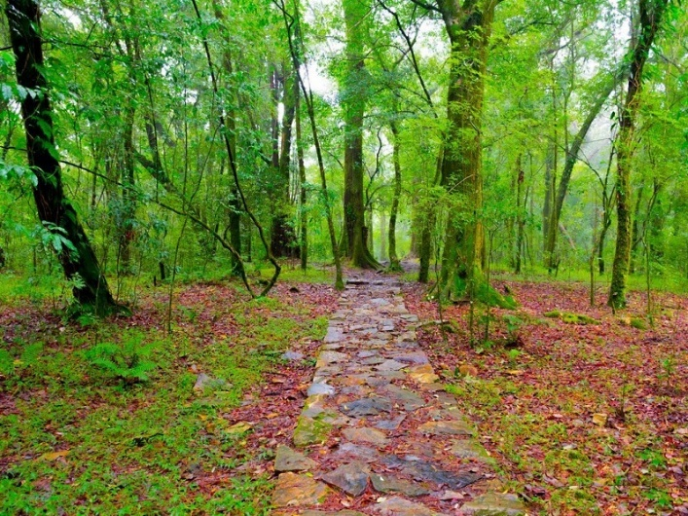

<https://www.trawell.in/admin/images/upload/648495572Shillong_Mawphlang_Sacred_Forest_Main.jpg>

2nd image:

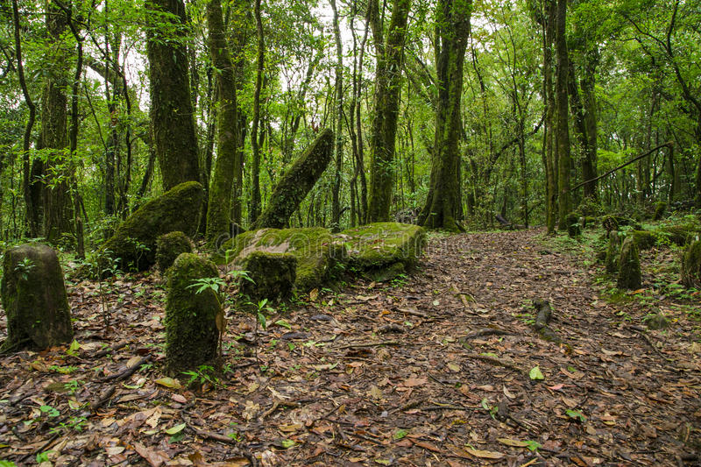

<https://thumbs.dreamstime.com/b/sacred-forest-mawphlang-pics-tribal-worship-place-shillong-north-east-india-46990926.jpg>